**How to set PULL BASED MECHANISM:**

Pull based mechanism will be achieved by the Webhook concept.

Pull based mechanism: **job will be triggered immediately if code changes were made.**

**We have to integrate Jenkins in the GitHub repository**

**Step-1:**

Create a Jenkins job for GitHub repository.

By selecting trigger job **Githubhook trigger for GITScm polling**

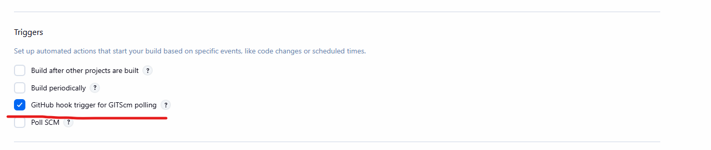

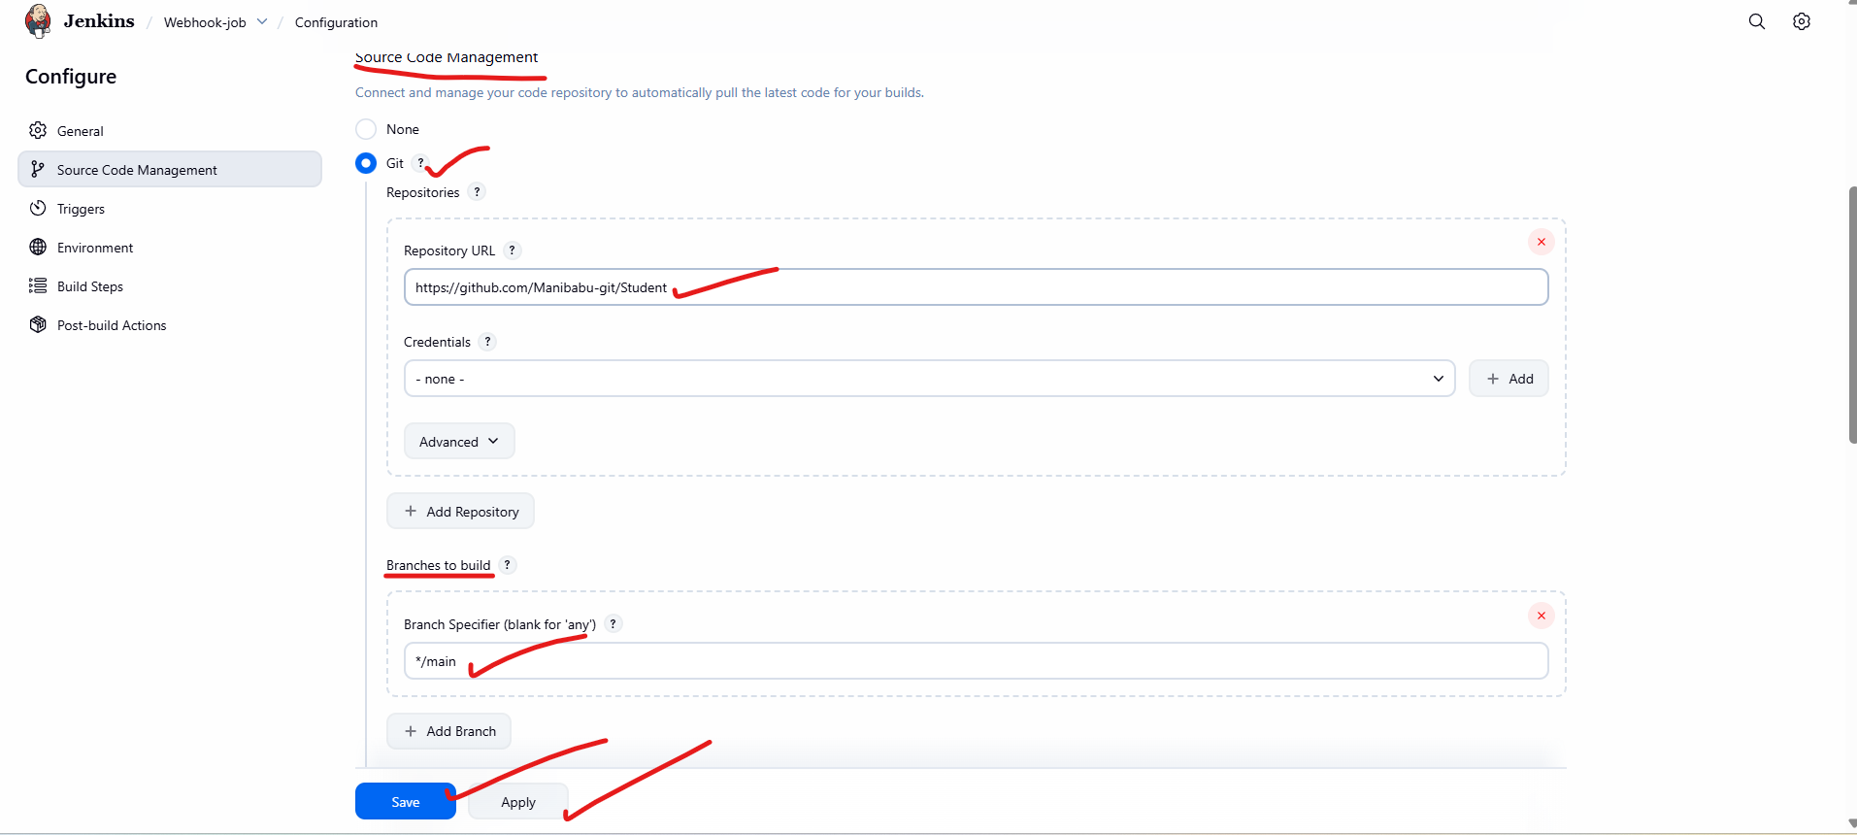

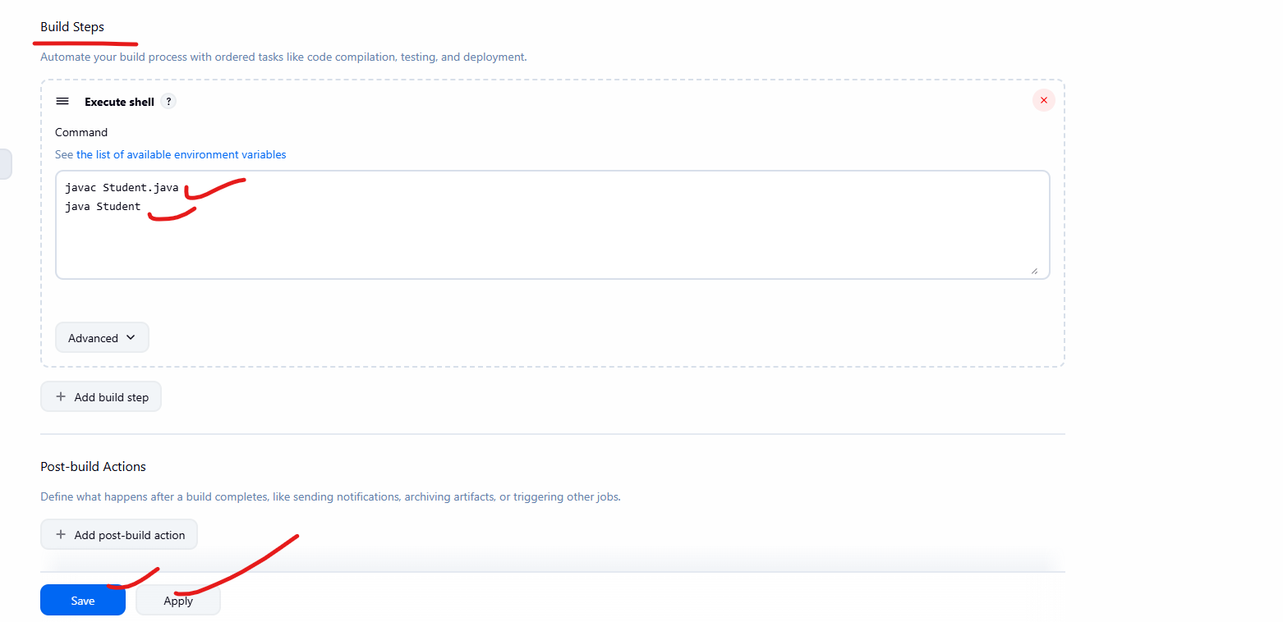

**Step-2:**

Integrate the Jenkins with the github repository.

1. Login into github and select the repo which we integrate with Jenkins
2. Click on settings

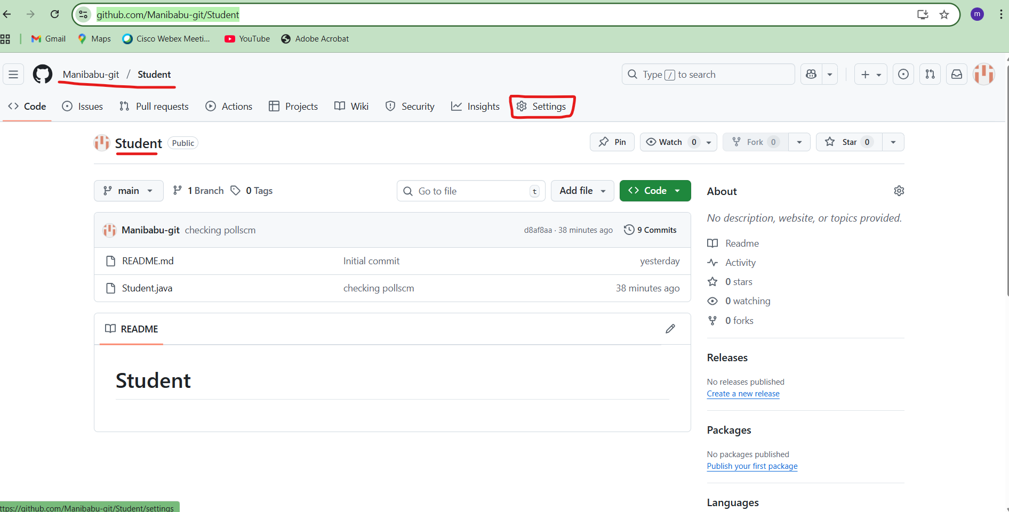

1. Click on webhook

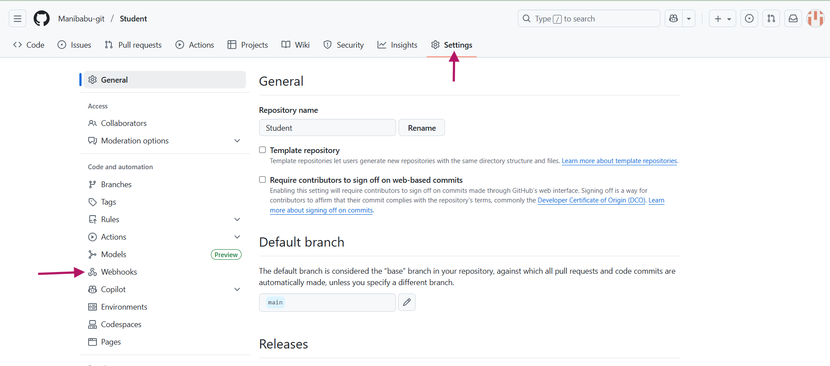

1. Click on Add Webhook
2. Provide the Jenkins dashboard url along with github-webhook

Ex: **http://54.162.161.235:8080/github-webhook/**

1. and select applicaton/json.
2. Click on Add webhook

